**MOTION SENSOR**

**ABOUT SENSOR:**

It is basically a PIR sensor (passive infrared sensor). This sensor is specially designed to detect the changes in levels of infrared radiation. It is used to detect the presence of a person or a thing near it.

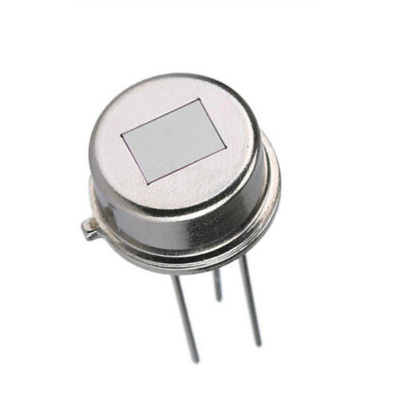

**WORKING:**

Passive infrared motion detectors (PIR) detect emitted infrared energy – given off by humans and animals in the form of heat. When there is a sudden increase in infrared energy, an alarm is sounded. Small fluctuations in infrared energy aren’t detected by the sensor which is good because the alarm would have get activated as the sun rises and sets or while there is a change in the household temperature slightly. In this way the motion detector works and mainly its used for the security purposes.

**INTERFACING OF THE SENSOR WITH ARDUINO UNO**

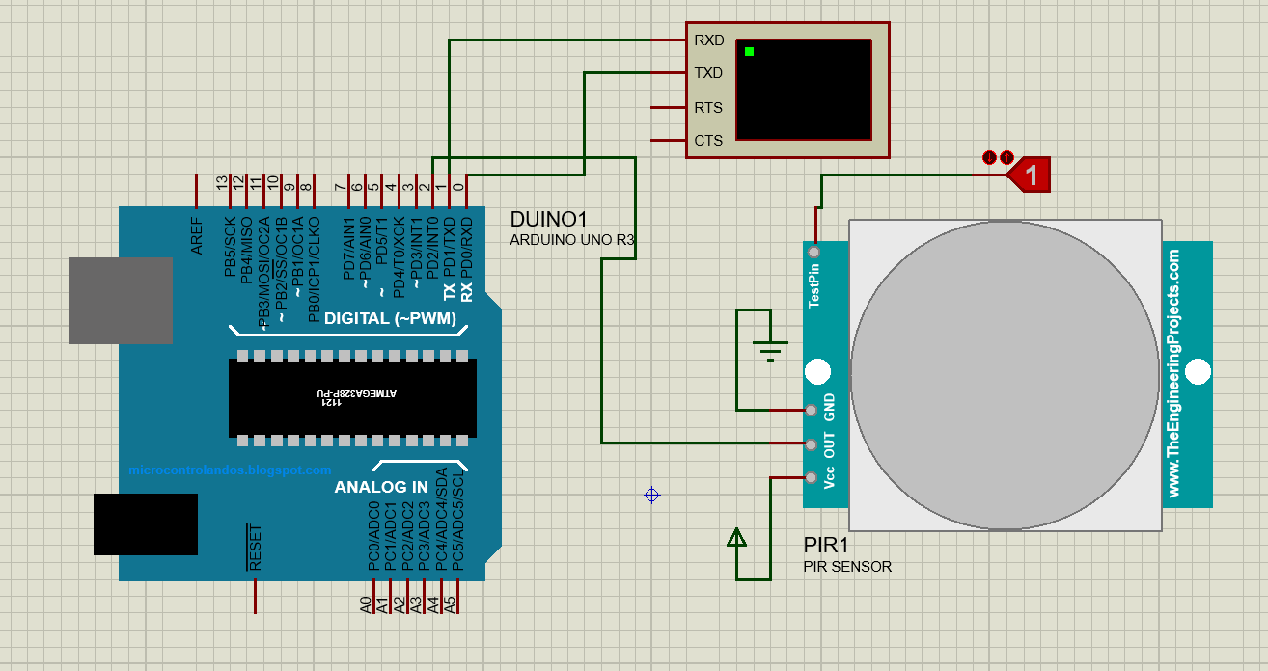

**PINOUTS:**

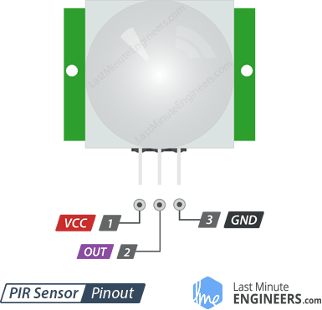

|  |  |  |
| --- | --- | --- |
| **PIN NUMBER** | **PIN NAME** | **PIN DESCRIPTION** |
| 1 | Vcc | The supply voltage of 5v is given to power the sensor from the Arduino. |
| 2 | Out | The output of the digital signal is taken from this pin. |
| 3 | Gnd | This pin is connected to the ground. |

**CODE:**

void setup() {

// put your setup code here, to run once:

pinMode(2,INPUT);

Serial.begin(9600);

}

void loop() {

// put your main code here, to run repeatedly:

int s=0;

s=digitalRead(2);

if(s!=0){

Serial.println(s);

delay(1000);

}

}